M.S.KIRUBA KARTHIK 192472004

CO2 AT1
A logistics application needs to group parcel IDs by destination city. Design a Map-based data structure in which each city is associated with multiple parcel IDs, and explain the insertion algorithm. [Map of Collections]
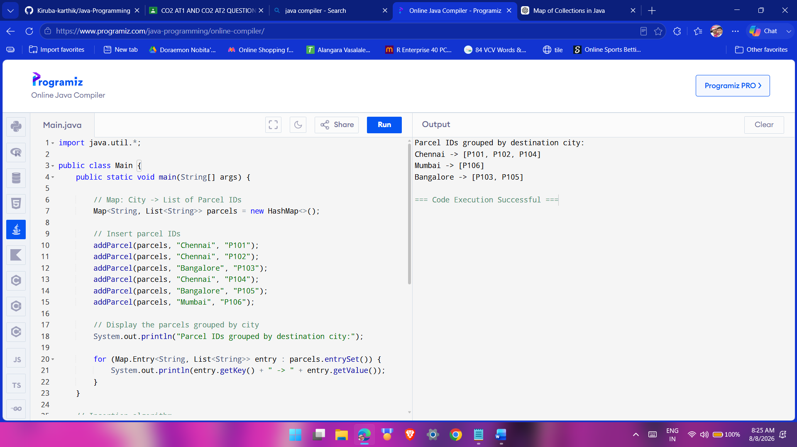

import java.util.*;

public class Main {
public static void main(String[] args) {

// Map: City -> List of Parcel IDs
Map<String, List<String>> parcels = new HashMap<>();

// Insert parcel IDs
addParcel(parcels, "Chennai", "P101");
addParcel(parcels, "Chennai", "P102");
addParcel(parcels, "Bangalore", "P103");
addParcel(parcels, "Chennai", "P104");
addParcel(parcels, "Bangalore", "P105");
addParcel(parcels, "Mumbai", "P106");

// Display the parcels grouped by city
System.out.println("Parcel IDs grouped by destination city:");

for (Map.Entry<String, List<String>> entry : parcels.entrySet()) {
System.out.println(entry.getKey() + " -> " + entry.getValue());
}
}

// Insertion algorithm
static void addParcel(Map<String, List<String>> map,
String city, String parcelId) {

// If city does not exist, create a new list
if (!map.containsKey(city)) {
map.put(city, new ArrayList<>());
}

// Add parcel ID to the city's list
map.get(city).add(parcelId);
}
}

Pseudo code :
START

Create an empty Map called parcels
where key = City
and value = List of Parcel IDs

CALL addParcel(parcels, "Chennai", "P101")
CALL addParcel(parcels, "Chennai", "P102")
CALL addParcel(parcels, "Bangalore", "P103")
CALL addParcel(parcels, "Chennai", "P104")
CALL addParcel(parcels, "Bangalore", "P105")
CALL addParcel(parcels, "Mumbai", "P106")

PRINT "Parcel IDs grouped by destination city:"

FOR each entry in parcels
PRINT city -> parcel IDs
END FOR

FUNCTION addParcel(map, city, parcelId)

IF city does not exist in map THEN
Create a new empty list
Add city and list to map
END IF

Get the list associated with city
Add parcelId to the list

END FUNCTION

END
CO2 AT2
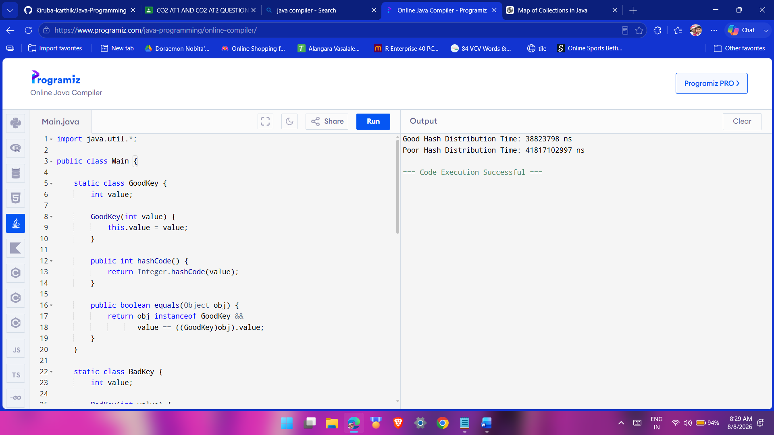
Evaluate HashMap collision-handling at a conceptual level. Explain how poor hash distribution affects performance and devise a test to reveal the problem. [Evaluate/Experiment]

import java.util.*;

public class Main {

static class GoodKey {
int value;

GoodKey(int value) {
this.value = value;
}

public int hashCode() {
return Integer.hashCode(value);
}

public boolean equals(Object obj) {
return obj instanceof GoodKey &&
value == ((GoodKey)obj).value;
}
}

static class BadKey {
int value;

BadKey(int value) {
this.value = value;
}

// Every key gets the same hash code
public int hashCode() {
return 1;
}

public boolean equals(Object obj) {
return obj instanceof BadKey &&
value == ((BadKey)obj).value;
}
}

public static void main(String[] args) {

int n = 100000;

HashMap<GoodKey, Integer> goodMap = new HashMap<>();
HashMap<BadKey, Integer> badMap = new HashMap<>();

long start = System.nanoTime();

for (int i = 0; i < n; i++)
goodMap.put(new GoodKey(i), i);

long goodTime = System.nanoTime() - start;

start = System.nanoTime();

for (int i = 0; i < n; i++)
badMap.put(new BadKey(i), i);

long badTime = System.nanoTime() - start;

System.out.println("Good Hash Distribution Time: "
+ goodTime + " ns");

System.out.println("Poor Hash Distribution Time: "
+ badTime + " ns");
}
}

Pseudo code:
START

Set n = 100000

Create goodMap as HashMap
Create badMap as HashMap

Record start time

FOR i = 0 to n-1
Create GoodKey with value i
Insert GoodKey and i into goodMap
END FOR

Calculate goodTime

Record start time

FOR i = 0 to n-1
Create BadKey with value i
Insert BadKey and i into badMap
END FOR

Calculate badTime

PRINT "Good Hash Distribution Time" and goodTime
PRINT "Poor Hash Distribution Time" and badTime

END

